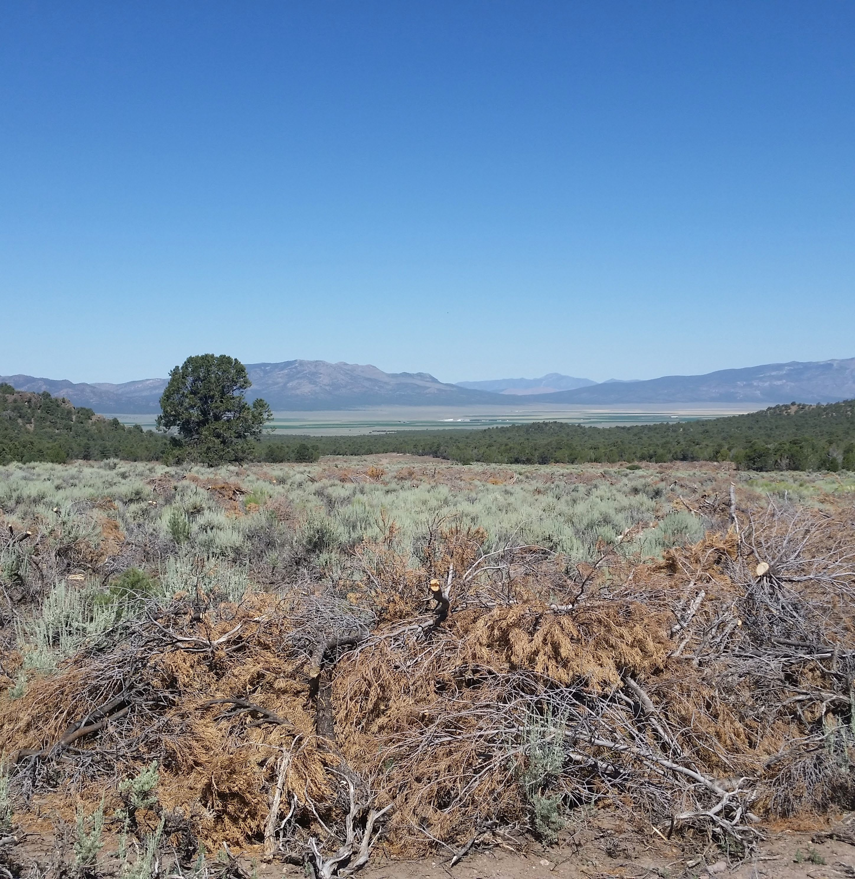
0

Lincoln County Conservation District Resource Needs Assessment General Population Survey Results

Authors
Michael H. Taylor, Associate Professor, Department of Economics, University of Nevada, Reno.
State Specialist, University of Nevada Cooperative Extension

Alec Bowman, Research Associate, Department of Economics, University of Nevada, Reno

Kimberly Rollins, Professor, Department of Agricultural and Resource Economics, University of Connecticut
Gary McCuin, Rangeland Specialist and County Educator, University of Nevada University Cooperative Extension

Sponsors
Nevada Association of Conservation Districts Clark County Cooperative Extension University of Nevada Cooperative Extension
USDA Natural Resource Conservation Service (NRCS)

U.S. Fish and Wildlife Service Nevada Department of Wildlife

Acknowledgements
We would like to thank the many people that contributed their time to improve the contents of the survey, organize focus groups, and ensure the success of the project. These individuals include Malieka Bordigioni, Inga Tissier, Maggie Orr, Rick Orr, Christiana Manville, and the participants of the focus group in Caliente, Nevada in March 2019.

To request an electronic copy of this report or if you have any questions about its contents, please contact Michael H. Taylor at taylor@unr.edu or (775) 784-1679.

Executive Summary
In 2018, the Lincoln County Conservation District (LCCD), along with seven other Nevada conservation districts, began a resource needs assessment (RNA) initiative. The goal of a RNA is to catalog the resource issues within a conservation district in order to assist the conservation district board in setting conservation priorities.
The RNA process has two parts: a technical assessment portion and a public input portion. The technical assessment for LCCD was conducted by Rick Orr and includes the resource concerns gathered through focus groups composed of natural resource professionals and individuals who live or work in each watershed within Lincoln County. The public input portion of the RNA is the focus of this document. We present the methods and results of the general population survey used to measure the resource concerns of a wide swath of Lincoln County residents. Both parts of the RNA process adopt the classification protocol of the USDA Natural Resource Conservation Services (NRCS) Resource Concerns Checklist planning tool.
This planning tool groups resource concerns into five major categories: soil, water, air, plants, and animals and is generally referred to as SWAPA.
The survey instrument was implemented in Lincoln County in June-July 2019.
Our study sample consists of 163 Lincoln County residents who completed the online survey. These 163 respondents are representative of Lincoln County’s demographics based on observable characteristics reported in the U.S. Census.
This document presents the results from the general population survey. The general population survey was designed so that the questions and modules correspond to the resource concerns on the Resource Concerns Checklist planning tool. This correspondence allows the survey results to be used in conjunction with the NRCS Resource Concerns Checklist planning tool in landscape level conservation planning in Lincoln County.
The results show that water quantity, water quality, and invasive weeds are the areas of greatest concern for residents of Lincoln County.
- Water quantity is the top natural resource concern for respondents in Lincoln County, with 71% of respondents listing it as a top three concern and 23% ranking it as their top concern. Respondent’s water quality concerns are driven by worries about the security of future water supplies and drought, as well as by concerns about future out of basin water transfers.

- Water quality was also a top natural resource concern for respondents in Lincoln County, with 50% of respondents listing it as top three concern. Respondent’s water quality concerns are driven by the quality of water in natural water bodies like lakes and rivers.
- Invasive weeds are another major resource concerns in Lincoln County, with 91% of respondents identifying invasive weeds as a concern (the highest of any category) and 23% identifying invasive weeds as their top concern (tied with water quantity). Concern about invasive weeds was shared equally by agricultural producers and non-agricultural producers.
- Ecological degradation from feral horses and resulting damages to livestock and wildlife were also a major concern, with 77% of respondents, identifying feral horses as a concern.
Agricultural producers represent an important constituency for LCCD. Resource issues of top concern for agricultural producers in Lincoln county were:
- Poor distribution of water on public lands.
- Poor quality of forage on public lands.
- Impacts from feral horses.
- Soil and property damage from flooding.
The findings in this report support the findings in the RNA technical assessment for LCCD, which were: major concern about habitat degradation and poor forage due to invasive weeds, and poor distribution of water on public lands leading to limited availability of water for livestock (Orr 2019). The general population survey indicates that concerns about water scarcity water quality in natural bodies of water are resource concerns of comparable importance to invasive weeds to the residents of Lincoln County.
In addition to the RNA questions, the survey also contained questions on the respondents’ outdoor recreation activities in Lincoln County, as well as questions related to LCCD’s current activities. Results indicate that the majority of residents in Lincoln County participated in some form of outdoor activity in the past year, with non-motorized trail use (i.e., hiking, walking pets, mountain biking) and off-highway vehicle (OHV) use as the most popular activities. Among non-motorized and OHV trail users, the primary concern was the limited number of trails. Results also indicate that there is limited public awareness of LCCD or its mission among the general public in Lincoln County.

Conservation Action Plan Development
The NRCS defines locally-led conservation as a process where community stakeholders are involved in natural resource planning, implementation of solutions, and evaluation of results (NRCS, 2010). The planning phase of the NRCS process has two parts: 1. Performing an RNA to gather public input from a range of stakeholders; and 2. Using input from the RNA to develop a conservation action plan (CAP) that identifies priorities, sets goals, and identifies government and nongovernment programs to achieve these goals. This section summarizes the major implications of this document (the public-input portion of the RNA) for the development of a CAP for LCCD.
- Priority: Water Availability
  - Goal: Ensure that water is available to meet demand in LCCD now and in the future.
  - Programs: Conservation programing to increase efficiency of irrigation systems and increase the availability of water on public lands for livestock and wildlife.
- Priority: Water Quality
  - Goal: Improve quality of lakes and rivers in LCCD.
  - Programs: Results indicate that programs to address invasive aquatic weeds would have substantial public support.
- Priority: Invasive weeds
  - Goal: Reduce prevalence of invasive weeds within LCCD.
  - Program(s): Results indicate broad support for programming targeted at removing invasive plants and noxious weeds, improving soil stability, and improving forage quality for livestock.
- Priority: Feral Horses
  - Goal(s): Limit the impact of feral horses on wildlife habitat and rangeland health.
  - Program(s): Work with the Bureau of Land Management to set management policy for feral horse herds that limit their negative impacts by reducing herd size in sensitive areas
- Priority: Recreational Areas
  - Goal(s): Increase the numbers of recreational trails for motorized and non- motorized users.

  - Program(s): Increase public awareness of existing trail systems. Develop new recreation trails.

Table of Contents

Executive Summary 1
Implications for the Conservation Action Plan 3
Table of Contents 5
- Introduction 7
Overview 7
Lincoln County Profile 7
Background 7
Natural Resources Conservation Service and SWAPA 7
Conservation Districts and Locally-Led Conservation 8
Resource Needs Assessment 8
- Survey Development & Implementation 10
Survey Development 10
Sampling 12
Sample Representation 13
- Resource Needs Assessment Results 14
Top Natural Resource Concerns 14
Top Ranked Concerns 15
Water Quantity 15
Water Quality 16
Plants and Invasive Weeds 17
Other Resource Concerns 21
Air Quality 21
Fish, Wildlife, and Habitat 21
Soil Stability and Erosion 21
- Recreation 25
Trail Use 25
OHV 26
Sightseeing 27
Target Shooting 28
Fishing & Hunting 29
- Lincoln County Conservation District 30
Public Awareness 30
Public Lands 30
Community Projects 31
- Bibliography 33
- Appendix 35
A1. Recruiter Instruction and FAQ sheet 35
A3. Invitation Card 37

Introduction

Overview
Nevada Association of Conservation Districts (NVACD) and the Lincoln County Conservation District (LCCD), along with six other Nevada CDs, partnered with researchers at the University of Nevada, Reno to develop and conduct a general population survey to measure the natural resource concerns of Lincoln County residents. The information acquired from this process will be used to help LCCD set conservation priorities to ensure their conservation programming addresses the most important issues to their constituency.

Lincoln County Profile
LCCD is entirely rural with a total population of just over 5,000 people (United States Census Bureau, 2010). Lincoln County’s population centers include Panaca, Pioche, Caliente, Alamo, and Rachel. Lincoln County is an arid county receiving two to eight inches of precipitation annually and has a mean annual temperature of
53.45 degrees Fahrenheit (WRCC, 2020).

Background
This section provides background on the role of the RNA process in locally-led conservation.

Natural Resources Conservation Service and SWAPA

After the dust bowl of the 1930s, it was apparent that farm-level soil conservation was key to preventing wind erosion. In response to the dust bowl, the Soil Conservation Service, later renamed Natural Resource Conservation Service (NRCS), was established. The mission of the NRCS “is to provide resources to farmers and landowners to aid them with conservation. Ensuring productive lands in harmony with a healthy environment is our priority” (NRCS, 2020).
NRCS relies on the SWAPA natural resource planning tool for their conservation work. Farmers, in conjunction with NRCS agents, can use this planning tool to determine the resource concerns on their property and develop a conservation plan

to address each concern. Ray Dotson, NRCS State Conservationist for Nevada, describes SWAPA as foundational to the mission and vision of NRCS. (Dotson, personal Communications, 2019).

Conservation Districts and Locally-Led Conservation
Locally-led conservation is defined as “a process used by local people to assess their natural resource conditions and needs, set goals, identify programs and other resources to solve those needs, develop proposals and recommendations, implement solutions, and measure their success” (NRCS, 2014). Among other functions, CDs are responsible for assisting NRCS to ensure that NRCS programs within the CD reflect locally-determined conservation objectives. The CD board works with NRCS to ensure the funding they provide is tailored to address the top resource concerns within the district (Dotson, personal Communications, 2019). To determine what the top resource concerns are the CD conducts a resource needs assessment (RNA).

Resource Needs Assessment
RNA typically have two parts. The first is a technical assessment, which is performed by conservation specialists who meet with natural resource professionals to discuss the most important resource concerns in the CD. This component is effective for understanding the state of natural resources from the point of view of those individuals who work with them daily. In Nevada, many CDs take the same boundaries as the county and, as a result, include urban, agricultural, and public lands. Because the technical assessment tends to focus on the natural resource professionals, they can miss the resource concerns of many of the constituents they are elected to represent.
The second component of the RNA, public input, attempts to capture the resource concerns of the general public in a CD. The public input portion of the CD- level RNA is the analog of the client objective in a farm-level RNA. For example, a farm-level client objective may include goals such as increase crop yield or limit loss of topsoil. The client objective allows NRCS to address the specific concerns of each land-manager. Since locally-led conservation is targeted at landscape-level rather than parcel-level conservation, it is challenging to assess the “client” objective because the client is the entire community. In order to incorporate the client objective for landscape-level conservation, the CD-level RNA must involve a process

where all stakeholders in the CD have an opportunity to express their resource concerns.
Traditionally, NRCS has relied on CDs and the formal Local Work Group and State Technical Advisory Committee process to ensure that local priorities are reflected in NRCS programming and spending or in other conservation programs. In regions where this process is not functioning as intended, or for organizations other than NRCS are interested in landscape-level conservation, a more direct method to obtain stakeholder input is through a general population survey. CDSN, along with a handful of other Nevada CDs, have elected to use the general-population survey describe in the document to measure the resource concerns held by the general public.

Survey Development & Implementation
This section describes the development and implementation of the survey instrument. This section also analyzes whether the survey sample is representative of the general population in Clark County.

Survey Development
Collecting public opinion on resource concerns according to the SWAPA framework presents several challenges. The most significant challenge is removing the jargon from the technical descriptions of natural resource concerns so that the survey questions are clear and easy-to-understand for the general public. Additional challenges include low response rates and non-representative sampling, which are not unique to this project, but are problems that arise in survey work in general.
This section discusses the survey development and how these challenges were overcome.
The SWAPA planning tool includes sentences such as, “Classic gully management is adequate to stop the progression of head cutting and widening and offsite impacts are minimized by vegetation and/or structures” (NRCS Resource Concerns Checklist). A general-population survey instrument that uses phrases directly from SWAPA would likely confuse respondents and result in a low completion rate. To ensure that the language of our survey was understandable to the general public, we subjected the survey instrument to intensive focus group testing. We conducted focus groups with natural resource professionals, CD board members, and the general public. The focus group participants took the survey and provided feedback on the strengths and weaknesses of the instrument. Not only did we ensure the language could be understood by the public at large, we were also able to confirm the interpretation of the question did not vary among different groups.
We conducted seven focus groups before implementation in Lincoln County. The first focus group was conducted at the Nevada Association of Conservation Districts annual meeting in November of 2018. The participants were a mix of natural resource professionals, and CD board members from around Nevada. On February 22, 2019 a focus group was conducted at the Nevada Department of Wildlife (NDOW) offices in Reno and was attended by NDOW employees. On March 19th, 2019 we conducted a focus group in Caliente, Nevada, which was attended by the

general public, natural resource professionals, and agricultural producers. Figure 2 shows the general developmental and implementation efforts.

Figure 1: Survey Development Timeline
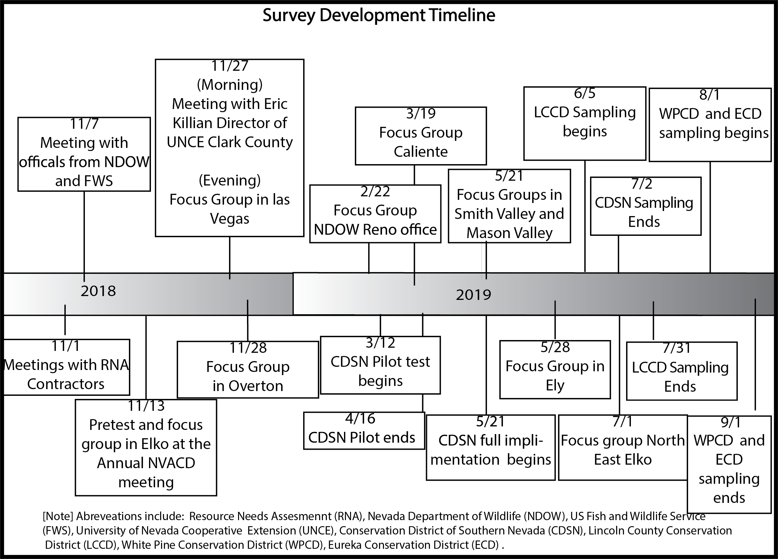

The focus group protocols were as follows:
  - Introduce the research and its importance.
  - Split the participants into smaller groups, no more than six. Each group will have a moderator taking notes. The moderator attempts to divide participants into groups composed of participants with similar propensity to speak. If groups are not formed in this way, discussion will often be dominated by one or two voices. The ideal groups will have equal input from all members.
  - Begin the survey. During the course of the survey the moderators encouraged the participants to vocalize their thoughts, ask clarifying questions, and state their objections to question appearance or content. Participants are even encouraged to have relevant conversation within the group. Observing how a question is explained by another participant gives

the designer a better idea of how the question is being perceived. Moderators then record participant responses and ask if certain questions are confusing based on the visual cues (e.g. squinting or pausing).
  - Once all surveys are completed, the debrief session begins, which is the time for overall feedback including initial reactions. In addition, the moderators ask the participants the following questions:
    - In your opinion, was anything missing?
    - Was there anything that would have made you put the survey down and not complete it?
    - Was the wording ever confusing?
    - Would you complete the survey if you were at home?
The moderators remained silent during the focus groups. Remaining silent allows the survey designer to view the nature of survey takers without being influenced by explanations from the researchers.
The four focus groups helped us find and remedy numerous faults in the survey instrument and aided in improvements. Our efforts proved successful, as the survey completion rate for LCCD was 94%. That is, 94% of individuals who opened the survey completed it in its entirety. . A copy of final survey instrument can be found at https://unrbusiness.az1.qualtrics.com/jfe/form/SV_eJUDxphGvEcVZSR

Sampling
The survey was implemented in Lincoln County in June and July 2019. The survey was implemented using “snowball sampling” (Baker, 2013). Snowball sampling relies on a hand full of “recruiters” who are known and trusted in the community to recruit community member to take the survey.
Each recruiter was given an instruction and sheet with information about the purpose of the survey and contact information for the researchers, as well as a list of frequently asked questions (Appendix A1). Recruiters were also given a stack of invitation cards to distribute to members of the community (Appendix A2). Each invitation card had a link to the online survey instrument, a unique password to access the survey, and contact information for the researchers. The recruiter personally invited community members to take the survey, explained the importance of their participation, and informed them of the raffle incentive.
Respondents in LCCD had the chance to enter a raffle for a $250 cash card upon

completion of the survey. The survey was implemented with the help of thirty recruiters Lincoln County.
This implementation strategy produced 163 completed surveys from a total population in Lincoln County of just over 5,000.

Sample Representation
This section compares the demographics of the LCCD survey sample with the population of Lincoln County using data on sex, race, and age from the U.S. Census (U.S. Census Bureau, 2010. Of the 163 respondents, 151 respondents provided information on their sex. The proportion sex ratio in our sample population was not significantly different than that of Lincoln County. 75 (49.67%) of the survey respondents were male while 72 (47.68%) were female (four respondents (2.65%) did not wish to specify). Our sample is majority white, with 150 (94.34%) of the respondents identifying as white and only two identifying as nonwhite (three respondents abstaining from answering the question). According to the 2010 Census, 91% of Lincoln County’s population identifies as white(U.S. Census Bureau, 2010). The proportion of white respondents in our sample is not is not significantly different from 91%. The average age of our sample is 45, which is younger compared to the mean age of 51 for rural Nevada (ACS 2018). Overall, our sample is representative of the population of LCCD based on observable characteristics, which gives us confidence that the natural resource concerns report in the survey accurately reflect the natural resource concerns of the broader Lincoln County population.

Resource Needs Assessment Results
This section presents the survey results on major resource concerns in LCCD, as well on the level of concern for each SWAPA category.

Top Natural Resource Concerns
Figure 2 shows that water quantity, water quality, and invasive weeds are the top ranked natural resource concerns in Lincoln County. Air quality, wildfire, access to nature, and wildlife habitat are the remaining resource concerns, in order of descending concern. These results do not suggest that respondents are unconcerned with the previously mentioned issues, but rather, when forced to make a tradeoff between resource issues LCCD respondents prioritize water quantity, water quality, and invasive weeds.

Figure 2: Top Resource Concerns for LCCD
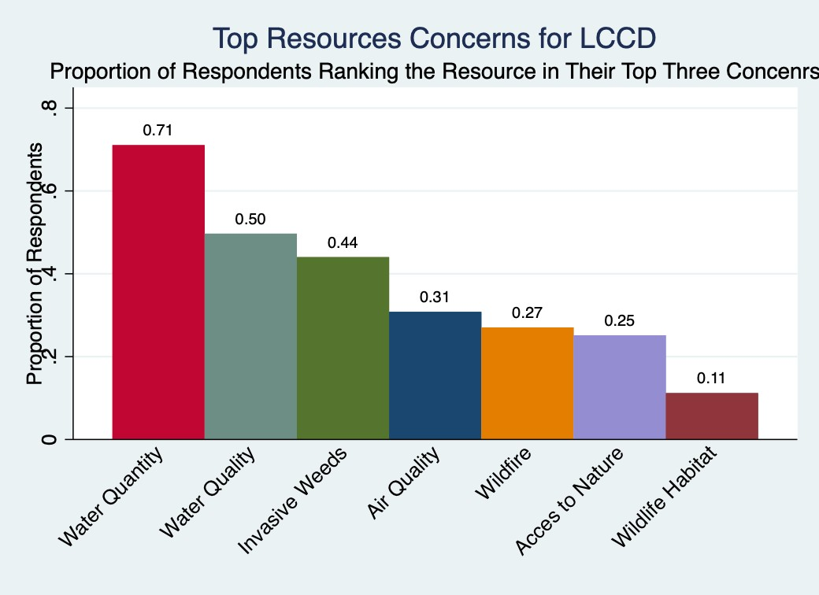

Top Ranked Concerns
Water Quantity

Water quantity is the top resource concern for respondents in LCCD, with 71% of respondents listing it as top three concern and 23% ranking it as their top concern. Respondents’ concerns over water quantity are driven by concerns about the security of future water supplies and drought. Table 1 shows 56% of respondents identifying the security of future water supplies as a concern, while 68% of respondents were concerned about future drought. A majority of respondents (66%) were also concerned with water leaving Lincoln County via out-of-basin transfers. Table 1 shows that agricultural producers and non-agricultural producers have similar levels of concern about these water supply issues. Table 1 also shows that concern about aquifer overdraft was less widespread in Lincoln, with only 41% of respondents stating that they were concerned about the issue.
While agricultural producers expressed similar levels of concern about water scarcity as producers, Table 1 reveals that agricultural producers expressed higher levels of concern about a number of water-related resource concerns. A majority of agricultural producers expressed high levels of concern about property damage (67%) and soil loss (59%) from flooding, while these flooding-related issues were not a concern for the majority of non-agricultural producers. A large majority of agriculture producers (86%) also expressed concern about the poor distribution of water on public lands.
Respondents were asked which water use activities should be prioritized given limited water supplies in Lincoln County. Figure 3 shows that large majorities of respondents ranked residential supply (96%), agriculture (88%), and wildlife (71%) as a top three water use priority. Other water use priorities such as business use and supporting new residential and commercial development were seen as lower priorities by the majority of respondents.

Figure 3: Water Use Priorities for LCCD
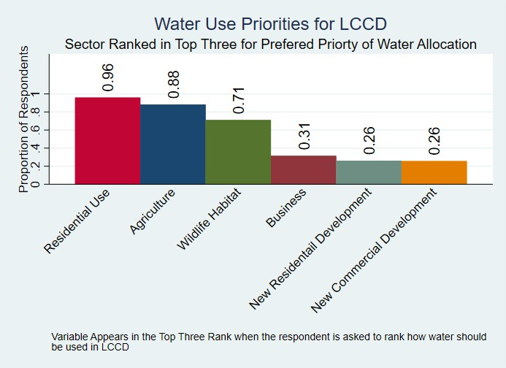

Water Quality

Water quality was also a top natural resource concern for respondents in Lincoln County, with 78% of respondents listing it as a concern and 50% of respondents listing it as top three concern. Table 2 shows that water quality was a lower priority concern for agricultural producers, with only 32% ranking it as a top three concern, than for non-agricultural producers. No specific water-quality related issue was a concern for a significant majority of respondents, with concern about the quality of water in natural water bodies like lakes and rivers reaching a bare majority (50%), while concern about drinking water quality (42%) and chemical contamination (29%) were lower level concerns.
Table 2 demonstrates how recreation-specific resource concerns are integrated into the SWAPA framework. For example, only respondents who indicated they

fished in the previous year were asked about reduced water quality, excessive algae growth, and aquatic invasive weeds. Table 2 shows that invasive aquatic weeds is a concern of 51% of fishers, while reduced water clarity (36%) and the related issued of algae growth (46%) were less significant concerns.

Plants and Invasive Weeds
Invasive weeds were indicated as the third most pressing resource issue by LCCD respondents. Invasive weeds are another major resource concerns in Lincoln County, comparable in importance to water scarcity. Table 3 shows that 91% of respondents identifying invasive weeds as a concern (the highest of any category) , 44% view invasive weeds as a top three concern, and 23% identifying invasive weeds as their top concern (tied with water quantity for the highest of any resource concern category). Table 3 shows that concern about invasive weeds was shared equally by agricultural producers and non-agricultural producers. In addition to invasive weeds, 83% of agricultural producers identified poor forage quality for livestock as a significant resource concern. (Only agricultural producers were asked about forage quality. Table 3 also shows that 30% of all respondents, and 50% of agricultural producers, are concerned about poor restoration response after wildfire.

Table 1: Water Quantity Concerns in the Lincoln County Conservation District

Water Quantity Concerns in the Lincoln County Conservation District
Resource Concerns |  | Statistic | Category of respondent
 |  | Statistic | All Respondents | Trail Users | Sightseers | Water  sports | OHV | Target  shooting | Fishing | Rock  Climber | Hunting | AG Producers | Involved in AG  (not Production)
Water Quantity |  | Top Ranked Concern | 23% | 25% | 26% | 23% | 23% | 17% | 21% | 23% | 19% | 32% | 29%
 |  | Top Three Ranked  Concern | 71% | 74% | 75% | 66% | 70% | 69% | 75% | 62% | 67% | 68% | 69%
 |  | Identified as a  concern | 81% | 82% | 87% | 84% | 80% | 83% | 84% | 85% | 78% | 86% | 77%
SWAPA Category* | Survey Question
Drought | Drought | Percent of respondents identifying the category as a concern | 68% | 70% | 71% | 74% | 63% | 68% | 72% | 72% | 62% | 63% | 59%
Aquifer Overdraft | Aquifer Overdraft | Percent of respondents identifying the category as a concern | 41% | 42% | 46% | 42% | 38% | 33% | 44% | 38% | 37% | 42% | 42%
Reduced Storage of Water Bodies / Insufficient Flows in  Watercourses | Low Surface water Levels | Percent of respondents identifying the category as a concern | 54% | 56% | 56% | 64% | 52% | 57% | 58% | 50% | 58% | 48% | 50%
Excessive Runoff, Flooding, or Ponding | Property damage from flash  flood | Percent of respondents identifying the category as a concern | 43% | 41% | 47% | 43% | 41% | 38% | 44% | 46% | 31% | 67% | 50%
Excessive Runoff, Flooding, or Ponding | Soil Damage from flooding | Percent of respondents identifying the category as a concern | 41% | 39% | 46% | 41% | 38% | 35% | 39% | 36% | 28% | 59% | 50%
Inadequate Stock Water | Poor Distribution of water on  public land | Percent of respondents identifying the category as a concern |  |  |  |  |  |  |  |  |  | 83%
na | Security of water supplies | Percent of respondents identifying the category as a concern | 56% | 59% | 61% | 57% | 53% | 57% | 58% | 58% | 48% | 52% | 52%
na | Out of Basin Tranfers | Percent of respondents identifying the category as a concern | 66% | 67% | 69% | 68% | 64% | 67% | 71% | 73% | 70% | 78% | 73%
 |  | Observations | 163 | 136 | 115 | 45 | 117 | 88 | 81 | 27 | 67 | 27 | 47
*SWAPA Category refers to the category in the NRCS Resource Concerns Checklist that most closely corresponds to the question in the RNA survey.

Table 2: Water Quality Concerns in the Lincoln County Conservation District

Water Quality Concerns in the Lincoln County Conservation District
Resource Concerns |  | Statistic | Category of respondent
 |  | Statistic | All Respondents | Trail Users | Sightseers | Water  sports | OHV | Target  shooting | Fishing | Rock  Climber | Hunting | AG Producers | Involved in AG  (not Production)
Water Quality |  | Top Ranked Concern | 16% | 16% | 19% | 20% | 14% | 20% | 20% | 15% | 17% | 7% | 13%
 |  | Top Three Ranked  Concern | 50% | 50% | 56% | 52% | 49% | 51% | 49% | 35% | 44% | 32% | 46%
 |  | Identified as a  concern | 78% | 79% | 83% | 84% | 79% | 80% | 88% | 77% | 81% | 75% | 77%
SWAPA Category* | Survey Question
Salinity, Nuitreints, etc. | Chemical Contamination | Percent of respondents identifying the category as a concern | 29% | 31% | 32% | 25% | 22% | 23% | 30% | 31% | 17% | 15% | 11%
Excessive Suspended  Sediment and Turbidity in Surface Water | Reduced water clarity | Percent of respondents identifying the category as a concern |  |  |  |  |  |  | 36%
Excessive Nutrients and  Organics in Surface Water | Growth of algae | Percent of respondents identifying the category as a concern |  |  |  |  |  |  | 46%
Excessive Nutrients and  Organics in Surface Water | Invasive aquadic weeds | Percent of respondents identifying the category as a concern |  |  |  |  |  |  | 51%
Excesive Salinity or other chemicals in  water | Excesive Salinity or other chemicals in water | Percent of respondents identifying the category as a concern |  |  |  |  |  |  |  |  |  | 8%
Reduced Capacity of Conveyances by  Sediment Deposition | Sediment in irrigation water | Percent of respondents identifying the category as a concern |  |  |  |  |  |  |  |  |  | 26%
Inadequate Stock Water | Poor water qualit for  livestock (pub lands) | Percent of respondents identifying the category as a concern |  |  |  |  |  |  |  |  |  | 33%
n/a | Quality of drinking water | Percent of respondents identifying the category as a concern | 42% | 42% | 48% | 34% | 37% | 34% | 40% | 38% | 31% | 44% | 41%
n/a | Quality of natural water  bodies | Percent of respondents identifying the category as a concern | 50% | 52% | 52% | 55% | 46% | 44% | 56% | 50% | 44% | 44% | 48%
 |  | Observations | 163 | 136 | 115 | 45 | 117 | 88 | 81 | 27 | 67 | 27 | 47
*SWAPA Category refers to the category in the NRCS Resource Concerns Checklist that most closely corresponds to the question in the RNA survey.

Table 3: Plant and Invasive Weed Concerns in the Lincoln County Conservation District

Plant and Invasive Weed Concerns in the Lincoln County Conservation District
Resource Concerns |  | Statistic | Category of respondent
 |  | Statistic | All Respondents | Trail Users | Sightseers | Water  sports | OHV | Target  shooting | Fishing | Rock  Climber | Hunting | AG Producers | Involved in AG  (not Production)
Plants and Invasive Weeds |  | Top Ranked Concern | 23% | 20% | 21% | 23% | 22% | 23% | 19% | 27% | 22% | 43% | 29%
 |  | Top Three Ranked  Concern | 44% | 41% | 42% | 43% | 44% | 44% | 40% | 54% | 41% | 68% | 50%
 |  | Identified as a  concern | 91% | 92% | 89% | 86% | 92% | 93% | 94% | 96% | 91% | 93% | 92%
SWAPA Category* | Survey Question
Noxious and Invasive  Plants | Invasive Weeds | Percent of respondents identifying the category as a concern |  | 86% | 87% | 82% | 87% | 86% | 88% | 93% | 82% | 85%
Noxious and Invasive  Plants | Invasive aquatic weeds | Percent of respondents identifying the category as a concern |  |  |  | 20% |  |  | 40%
Forage Quality and  Palatability | Poor quality Forage for  Livestock (Pub Land) | Percent of respondents identifying the category as a concern |  |  |  |  |  |  |  |  |  | 83%
Plant disease | Plant disease | Percent of respondents identifying the category as a concern |  |  |  |  |  |  |  |  |  | 17%
Wildfire | Poor restoration response  after wildfire | Percent of respondents identifying the category as a concern | 30% | 32% | 41% | 27% | 33% | 33% | 34% | 32% | 33% | 50% | 44%
 |  | Observations | 163 | 136 | 115 | 45 | 117 | 88 | 81 | 27 | 67 | 27 | 47
*SWAPA Category refers to the category in the NRCS Resource Concerns Checklist that most closely corresponds to the question in the RNA survey.

Other Resource Concerns
Air Quality
Table 4 shows while air quality was ranked in the top three resource concerns by 31% of respondents, no single air quality issue was indicated as a concern by a majority of respondents. This suggests that the air quality concerns are not directly linked to an underlying resource issue in Lincoln County in the minds of the respondents.

Fish, Wildlife, and Habitat
Table 5 shows that while concern for wildlife habitat was ranked as a top three concern by only 11% of respondents, 87% of respondents expressed concern with at least one fish and wildlife related resource issue. This includes competition from feral horses, which was indicated as a concern by 77% of respondents, including 89% of agriculture producers and 95% of hunters. A majority of respondents (52%) were concerned about by an over-abundance of rodents and other pests. Concerns over feral horses were also voiced frequently in the comment field at the end of the survey. Poor habitat quality, poaching, and habitat fragmentation were also indicated as concerns by a majority of hunters and sightseers seeking wildlife.
Table 5 also shows that other issues such as inadequate shelter and cover for wildlife, inadequate quantities of water, competition from livestock, and increased human presence affecting animals were not viewed as significant concerns by a majority of respondents.

Soil Stability and Erosion
Table 6 shows that 74% of respondents have at least one soil resource concern.
Concern about soil damage from flooding is share by 41% of all respondents and 59% of agriculture producers. Streambank erosion was a concern for both fishers (50%) and agricultural producers (40%), the only two groups asked about streambank erosion.
Table 6 also shows that excessive dust was not viewed as a significant concern by a majority of respondents. Soil salinity was not viewed as significant concerns by a majority of agricultural producers (only agricultural producers were asked about soil salinity).

Table 4: Air Quality Concerns in the Lincoln County Conservation District

Air Quality Concerns in the Lincoln County Conservation District
Resource Concerns |  | Statistic | Category of respondent
 |  | Statistic | All Respondents | Trail Users | Sightseers | Water  sports | OHV | Target  shooting | Fishing | Rock  Climber | Hunting | AG Producers | Involved in AG  (not Production)
Air Quality |  | Top Ranked Concern | 6% | 4% | 4% | 0% | 5% | 6% | 6% | 0% | 6% | 0% | 2%
 |  | Top Three Ranked  Concern | 31% | 31% | 27% | 32% | 31% | 29% | 33% | 27% | 30% | 18% | 23%
 |  | Identified as a  concern | 40% | 42% | 43% | 45% | 36% | 30% | 38% | 50% | 33% | 32% | 33%
SWAPA Category* | Survey Question
Excessive Greenhouse Gas, PM 2.5 | Industrial air pollution | Percent of respondents identifying the category as a concern | 6% | 6% | 8% | 4% | 5% | 6% | 6% | 11% | 4% | 4% | 7%
Excessive Greenhouse Gas, PM 2.5 | Vehicle exhaust | Percent of respondents identifying the category as a concern | 5% | 4% | 6% | 4% | 2% | 1% | 4% | 4% | 0% | 0% | 0%
Excessive Greenhouse Gas, PM 2.5 | Wildfire smoke | Percent of respondents identifying the category as a concern | 20% | 21% | 24% | 22% | 17% | 11% | 16% | 22% | 12% | 12% | 14%
Particulate matter less than 10 micrometers in diameter (PM 10) | Dust from OHV | Percent of respondents identifying the category as a concern |  |  |  |  | 19%
 | Dust on windy days | Percent of respondents identifying the category as a concern | 29% | 29% | 30% | 29% | 21% | 17% | 25% | 30% | 18% | 27% | 24%
 |  | Observations | 163 | 136 | 115 | 45 | 117 | 88 | 81 | 27 | 67 | 27 | 47
*SWAPA Category refers to the category in the NRCS Resource Concerns Checklist that most closely corresponds to the question in the RNA survey.

Table 5: Fish and Wildlife Concerns in the Lincoln County Conservation District

Fish and Wildlife Concerns in the Lincoln County Conservation District
Resource Concerns |  | Statistic | Category of respondent
 |  | Statistic | All Respondents | Trail Users | Sightseers | Water  sports | OHV | Target  shooting | Fishing | Rock  Climber | Hunting | AG Producers | Involved in AG  (not Production)
Fish and Wildlife |  | Top Ranked Concern | 6% | 6% | 5% | 9% | 7% | 7% | 8% | 4% | 9% | 0% | 4%
 |  | Top Three Ranked  Concern | 11% | 10% | 6% | 6% | 13% | 9% | 12% | 10% | 17% | 10% | 11%
 |  | Identified as a  concern | 87% | 87% | 89% | 93% | 89% | 91% | 96% | 85% | 100% | 79% | 81%
SWAPA Category* | Survey Question
Threatened and Endangered Fish and Wildlife Species | Threats to at risk or endangered species | Percent of respondents identifying the category as a concern | 24% | 26% | 26% | 27% | 20% | 15% | 19% | 31% | 13% | 15% | 15%
Inadequate Water | Inadequate quantity of water  for wildlife | Percent of respondents identifying the category as a concern |  |  | 21% |  |  |  |  |  | 11%
Inadequate  Cover/Shelter | Threats to wildlife habitat | Percent of respondents identifying the category as a concern | 36% | 37% | 41% | 36% | 33% | 29% | 38% | 35% | 28% | 33% | 41%
Population Imbalance | Abundance of rodents or  pests | Percent of respondents identifying the category as a concern | 52% | 50% | 50% | 43% | 48% | 44% | 49% | 38% | 41% | 52% | 50%
Population Imbalance | High number of predators | Percent of respondents identifying the category as a concern | 27% | 24% | 25% | 30% | 25% | 27% | 24% | 31% | 28% | 26% | 26%
Population Imbalance | Competition from feral  horses | Percent of respondents identifying the category as a concern | 77% | 80% | 75% | 84% | 83% | 87% | 84% | 81% | 95% | 89% | 87%
Population Imbalance | High numbers of undesirable  fish | Percent of respondents identifying the category as a concern |  |  |  |  |  | 39%
Habitat Fragmentation | Wildlife habitat broken by  roads and buildings | Percent of respondents identifying the category as a concern |  |  | 54% |  |  |  |  |  | 56%
Habitat Fragmentation | Habitat loss from wildfire | Percent of respondents identifying the category as a concern |  |  | 29% |  |  |  |  |  | 25%
n/a | Competition from livestock | Percent of respondents identifying the category as a concern |  |  | 13% |  |  |  |  |  | 13%
n/a | Poaching | Percent of respondents identifying the category as a concern |  |  | 63% |  |  |  |  |  | 60%
n/a | Poor habitat quality | Percent of respondents identifying the category as a concern |  |  | 49% |  |  |  |  |  | 52%
n/a | Increased human presence  affecting animals | Percent of respondents identifying the category as a concern |  |  | 25% |  |  |  |  |  | 21%
 |  | Observations | 163 | 136 | 115 | 45 | 117 | 88 | 81 | 27 | 67 | 27 | 47
*SWAPA Category refers to the category in the NRCS Resource Concerns Checklist that most closely corresponds to the question in the RNA survey.

Table 6: Soil Concerns in the Lincoln County Conservation District

Soil Concerns in the Lincoln County Conservation District
Resource Concerns |  | Statistic | Category of respondent
 |  | Statistic | All Respondents | Trail Users | Sightseers | Water  sports | OHV | Target  shooting | Fishing | Rock  Climber | Hunting | AG Producers | Involved in AG  (not Production)
Soil |  | Identified as a  concern | 74% | 76% | 79% | 73% | 71% | 70% | 69% | 69% | 67% | 82% | 77%
SWAPA Category* | Survey Question
Wind erosions | Excessive Dust | Percent of respondents identifying the category as a concern | 30% | 30% | 31% | 30% | 22% | 18% | 25% | 31% | 19% | 27% | 24%
Sheet & rill erosion | Soild Damage from flooding | Percent of respondents identifying the category as a concern | 41% | 39% | 46% | 41% | 38% | 35% | 39% | 36% | 28% | 59% | 50%
Soil Compaction | Users going off trail | Percent of respondents identifying the category as a concern |  | 31% |  |  | 32%
Ephemeral Gully | Ruts in trails | Percent of respondents identifying the category as a concern |  | 43%
Soil Salinity | Soil Salinity (public lands ) | Percent of respondents identifying the category as a concern |  |  |  |  |  |  |  |  |  | 0%
Soil Salinity | Soil Salinity (private land) | Percent of respondents identifying the category as a concern |  |  |  |  |  |  |  |  |  | 29%
Stream Bank Erosion | Stream Bank Erosion | Percent of respondents identifying the category as a concern |  |  |  |  |  |  | 50% |  |  | 40%
 |  | Observations | 163 | 136 | 115 | 45 | 117 | 88 | 81 | 27 | 67 | 27 | 47
*SWAPA Category refers to the category in the NRCS Resource Concerns Checklist that most closely corresponds to the question in the RNA survey.

Recreation
In addition to the natural resource related questions, the survey included questions regarding recreation activities. This section presents the results of these questions. Figure 4 below shows the proportion of respondents that participate in each outdoor recreation activity in Lincoln County in the past year. Figure 4 reveals that non-motorized trail use (i.e., hiking, walking pets, mountain biking), off-highway vehicle (OHV) use, sightseeing, target shooting, and fishing are the most popular recreational activities, with a majority of respondents indicating that they participated in these activities in the past year. Hunting is also popular, with 40% of respondents having participated in the previous year.
Figure 4: Outdoor Recreation Participation
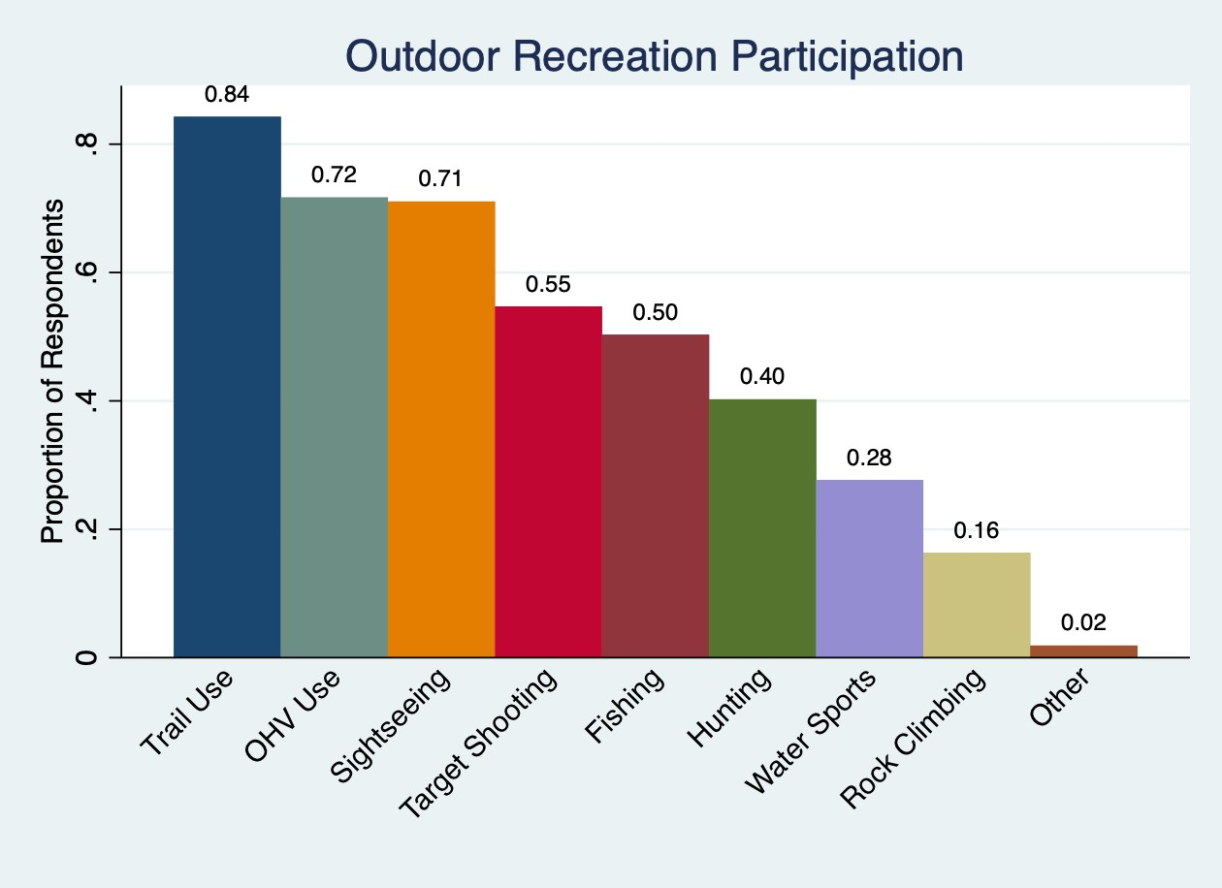

Trail Use
Figure 4 shows that non-motorized trail use is the most popular recreation activity among respondents, with 84% of respondents reporting

having participated in the previous year. Figure 5 shows that of the type of trail use, hiking is the most popular trail use activity in Lincoln County, followed by walking pets, running, biking, and horseback riding. Trail users report high levels of concern over the limited number of trails (50% of trail users), as well as poor trail maintenance (40% of trail users).
Figure 5: Types of Trail Use in LCCD
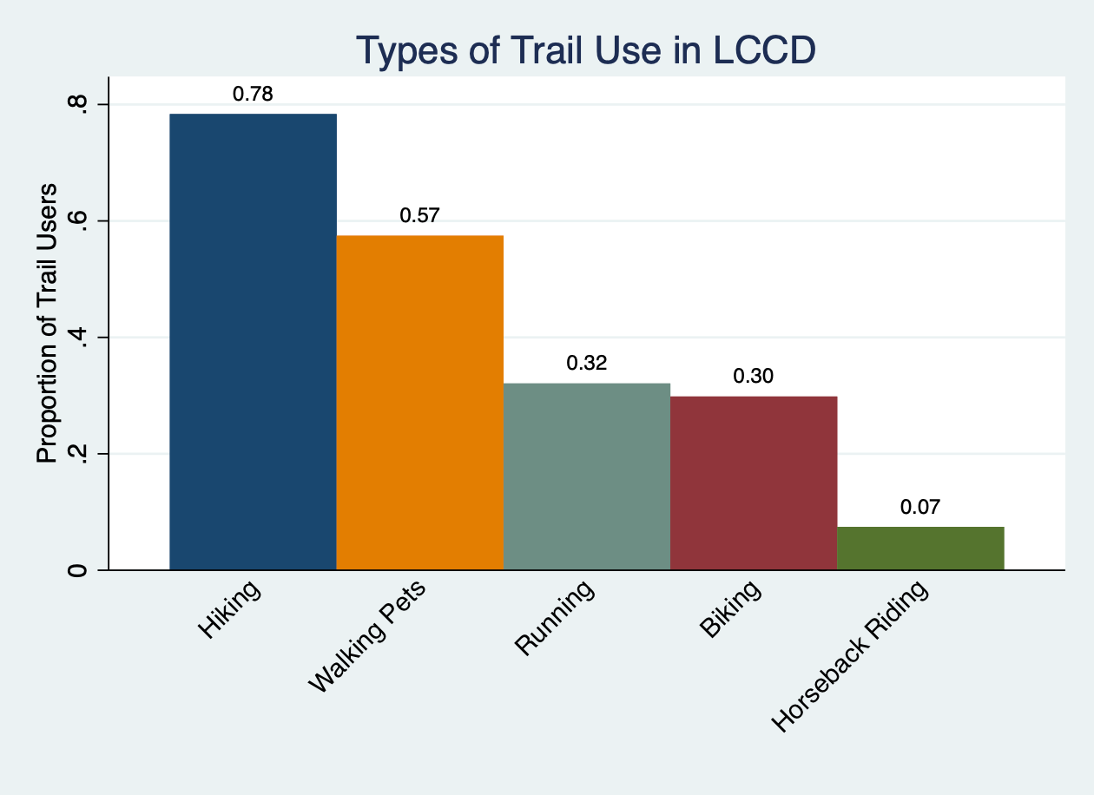

OHV
Figure 4 shows that OHV use is the most popular recreation activity among respondents, with 72% of respondents reporting having participated in the previous year. Figure 6 show that while most OHV users use OHV for recreation or to support other recreation activities (e.g., hunting), a substantial portion of OHV users use OHVs to support their ranching operation. OHV user’s only significant OHV-related concern is that 40% of them indicate that there are not enough OHV trails in Lincoln County.

Figure 6: Uses for OHV in LCCD
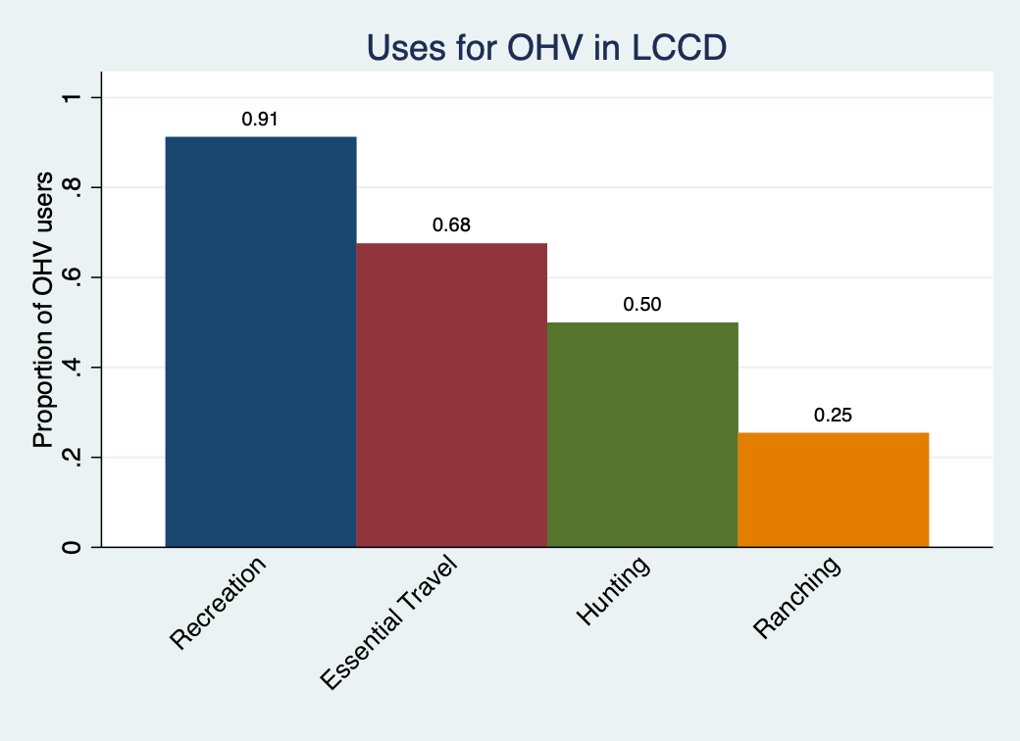

Sightseeing
Figure 4 shows that sightseeing is the third most popular activity for respondents in LCCD, with 71% of respondents reporting having participated in the previous year. Figure 7 indicates that public lands (BLM and USFS) and State Parks are the most popular sightseeing locations in Lincoln County. Sightseers did not express significant levels of concern for any sightseeing-related question included in the survey (e.g., too few areas, busy areas, and degraded areas for sightseeing).

Figure 7: Locations Used by Sightseers in LCCD
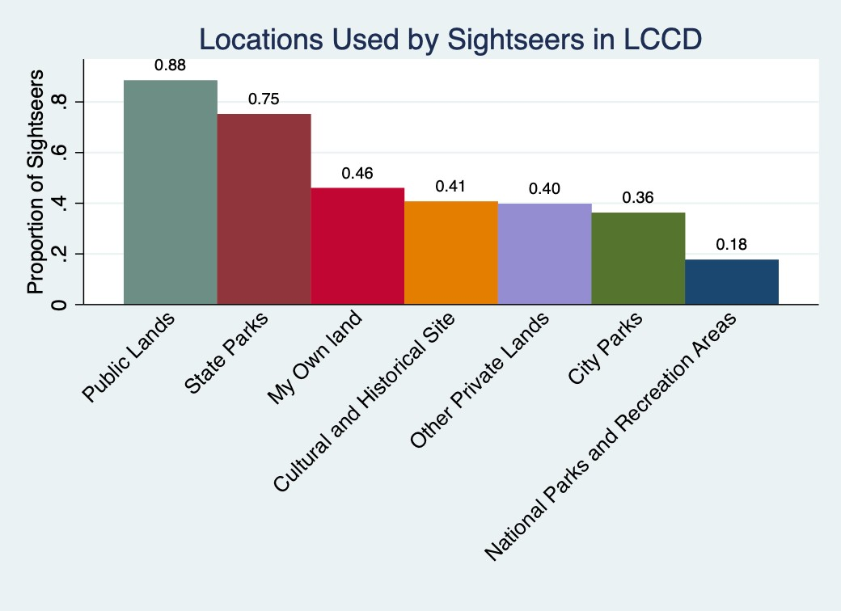

Target Shooting
Table 4 shows that target shooting is the fourth most popular activity among respondents from LCCD, with 55% of respondents reporting having participated in the previous year. Figure 8 shows that public ranges and public land are the most used target shooting locations in LCCD followed by private land and private range. 53% of target shooters indicate litter in popular shooting areas as a concern, which is the highest level of concern indicated among all recreation concerns across all recreational user groups. This suggests that stricter enforcement of litter on public ranges and public land could substantially improve the quality of shooters experience in Clark County. Further, 40% of target shooters indicate that there too few areas to shoot in LCCD. Increasing the number of public ranges could both address this concern and lower the litter related to congestion on existing ranges.

Figure 8: Locations Used by Target Shooters in LCCD
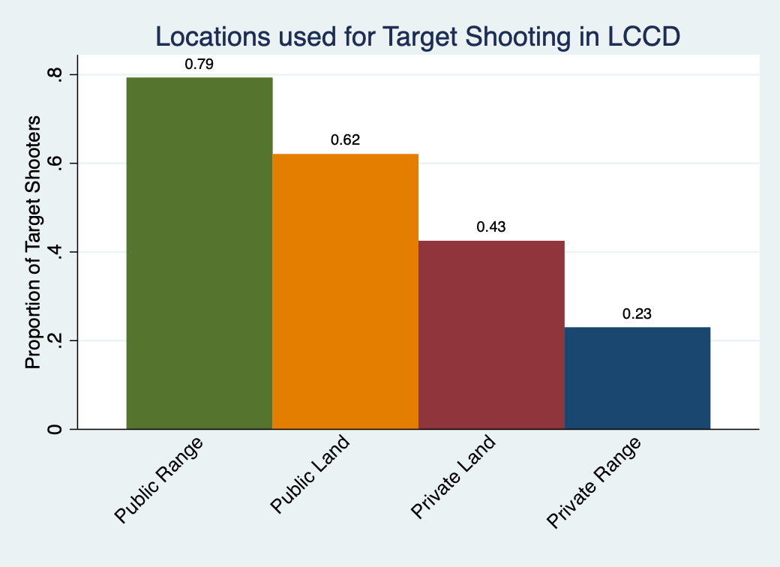

Fishing & Hunting
Figure 4 shows that fishing and hunting are the fifth and sixth most popular recreation activity among respondents, with 50% of respondents reporting having fished in the previous year and 40% of reporting having hunted in the previous year. The vast majority of respondents who fish do so in lakes and reservoirs rather than streams and creeks, and only a small percentage of fishers (22%) report difficulty accessing lakes and reservoirs from public lands. For hunters, while 40% of hunters report difficulty accessing public lands, there is virtually no concern over encountering fences on public land and the difficulty finding gates along those fences. As such, the survey results do not point towards a clear policy solution to remedy hunters concerns about accessing public land

Lincoln County Conservation District
This section describes the results from questions regarding LCCD and some of its current activities. These questions include focus on public awareness of LCCD’s activities, public sentiment on public lands management priorities, which is important given the extent of public lands in Lincoln County, and the community development priorities for LCCD.

Public Awareness
The survey included questions about the respondents’ awareness of LCCD and its activities. Only 40% of respondents reported knowing what LCCD does, which suggests that LCCD would benefit from a public relations campaign focused on raising awareness of the organizations mission and on-going activities. Further, the results suggest that the public’s lack of understanding of what LCCD does is not due to respondents being completely unaware of LCCD. The survey found that 46% of respondents reported knowing who works for the CD and 52% of respondents reported knowing how to contact the CD.

Public Lands
The majority of land in LCCD’s jurisdiction is public land managed by the federal government. Figure 9 reports results on how respondents believe public lands in Lincoln County should be managed. Figure 9 shows that a majority of respondents support managing public lands to accommodate recreation (77%), maintain areas of archaeological importance (69%), promote wildlife habitat (69%), support economic activity (67%), and protect against wildfire (62%). There was less support for managing public lands to support new residential (43%) or commercial (36%) real estate development (43%) or to support the U.S. military (36%). These results and indicate that general public in Lincoln County favors managing public lands for multiple uses, including promoting wildlife and recreation, over a narrow focus on economic development.

Figure 9: Public Lands Management Sentiment in LCCD
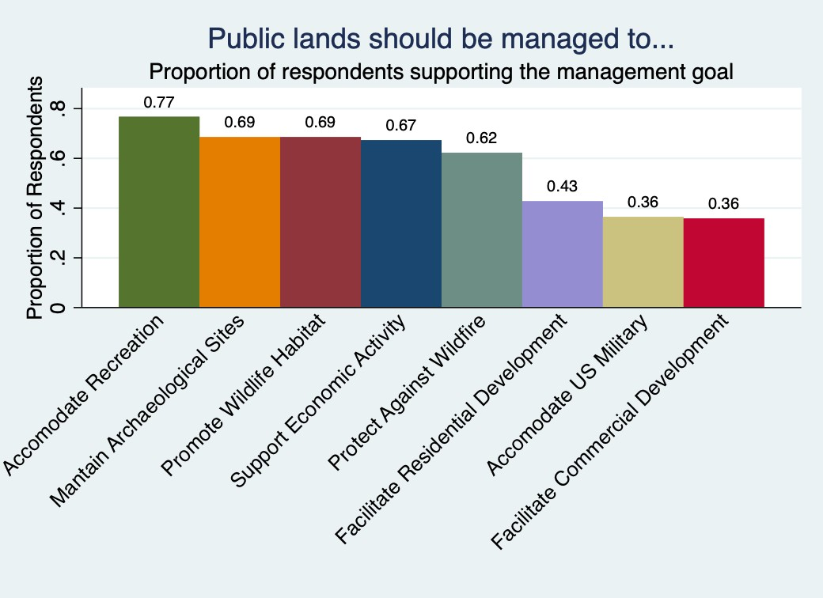

Community Projects
Figure 10 reports the results on respondents top three ranked when community development goal. Figure 10 shows that while 90% of respondents ranked economic development as their top three priorities, the most of any community development goal, support was spread pretty evenly across the five goals, with all goals ranked in the top three by at least 70% or respondents. These results indicate that there is a desire among Lincoln County residents for community investment across a number of dimensions.

Figure 10: Community Project Priorities
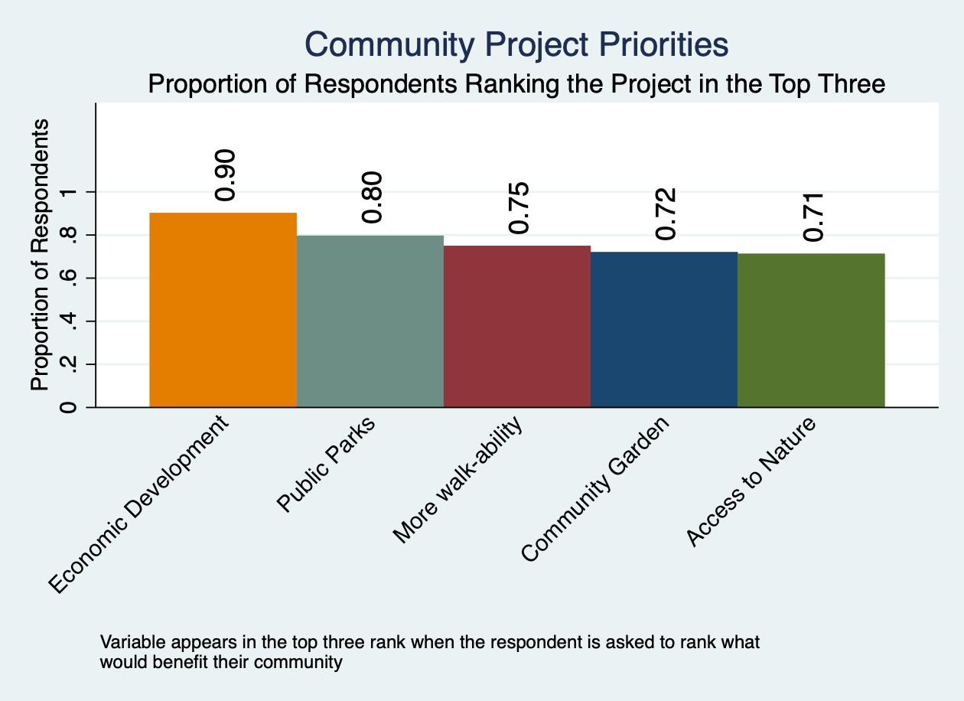

Bibliography

American Community Survey Data. 2017. United States Census Bureau. Data Accessed 2/25/2020.
Baker, et. al. 2013. REPORT OF THE AAPOR TASK FORCE ON NON-PROBABILITY SAMPLING. Link:
https://www.aapor.org/AAPOR_Main/media/MainSiteFiles/NPS_TF_Re port_Final_7_revised_FNL_6_22_13.pdf . Date Accessed 9/2/2020

Dotson, Ray. Personal Communications. December 30th, 2019. Via Phone call.

Evans, Jim. 2019. CONSERVATION DISTRICT OF SOUTHERN NEVADA 2018- 2020 RESOURCE NEEDS ASSESSMENT CONSERVATION REPORT 1.0.
https://drive.google.com/file/d/1gtOZWLDPJyMhUfyZrMtXdD2EKTtl1o AR/view Date Accessed 9/2/2020

NRCS, 2020. Information posted to the NRCS website: https://www.nrcs.usda.gov/wps/portal/nrcs/main/national/people/ Date Accessed 9/2/2020
NRCS, 2014. National Planning Procedures Handbook. First Edition. https://directives.sc.egov.usda.gov/OpenNonWebContent.aspx?conten t=36483.wba Date Accessed 9/2/2020

NRCS. 2010. Locally-Led Conservation Defined. NRCS Web Pages. Link: https://directives.sc.egov.usda.gov/viewerFS.aspx?hid=27713 Date Accessed 9/15/20.
NRCS Resource Concerns Checklist. Natural Resource Conservation Service.
Download here: https://www.nrcs.usda.gov/wps/PA_NRCSConsumption/download?cid
=nrcseprd927427&ext=pdf Date Accessed 9/2/2020

NVACD. 2019. Nevada Association of Conservation Districts Resource Needs Assessment. Link: http://www.nvacd.org/resource-needs-assessment Date Accessed 9/2/2020

Orr, Richard. 2019. Resource Needs Assessment, Lincoln County NV. https://drive.google.com/file/d/1_oWWWM7Z8708cfDLW3pJMwdwlF MCMW61/view Date Accessed 9/2/2020

Tolonen, Hanna, et al. "25-year trends and socio-demographic differences in response rates: Finnish adult health behaviour survey." European journal of epidemiology 21.6 (2006): 409-415.
United States Census Bureau, 2010. American Fact Finder. Accessed 2/25/2020. Link
WRCC, 2020. Western Regional Climate Center Temperature and Precipitation Database. https://wrcc.dri.edu/ Date Accessed 9/2/2020

Appendix

A1. Recruiter Instruction and FAQ sheet



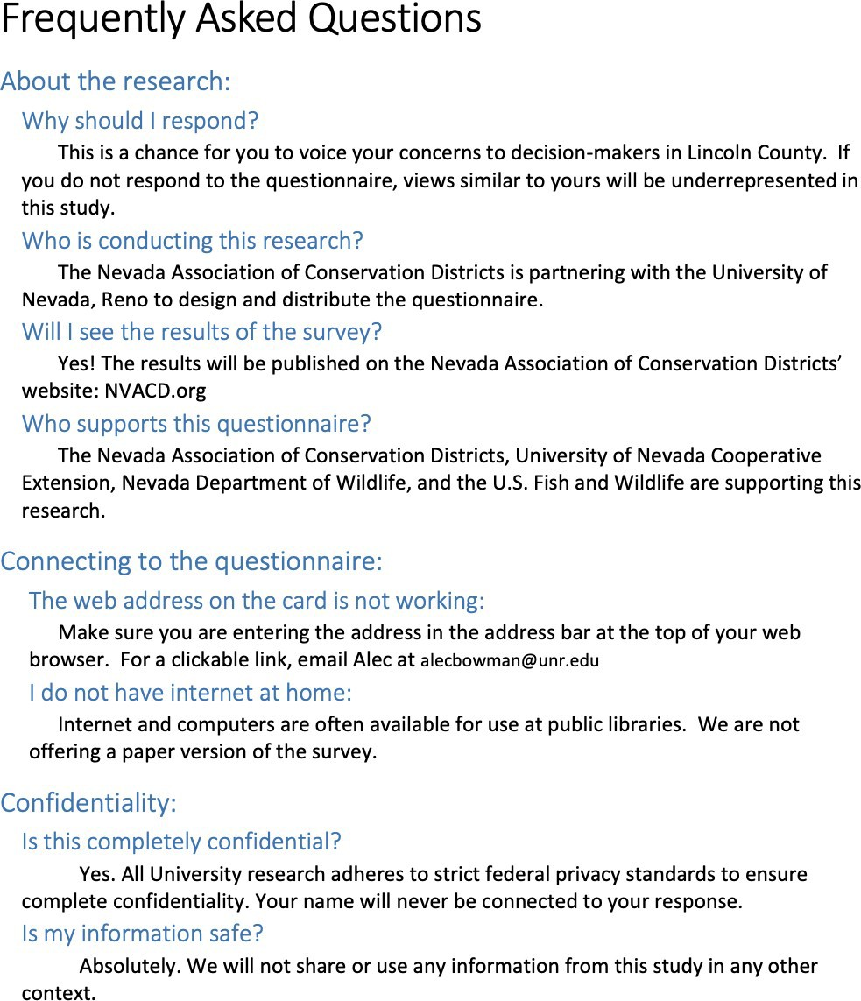

A2. Invitation Card
